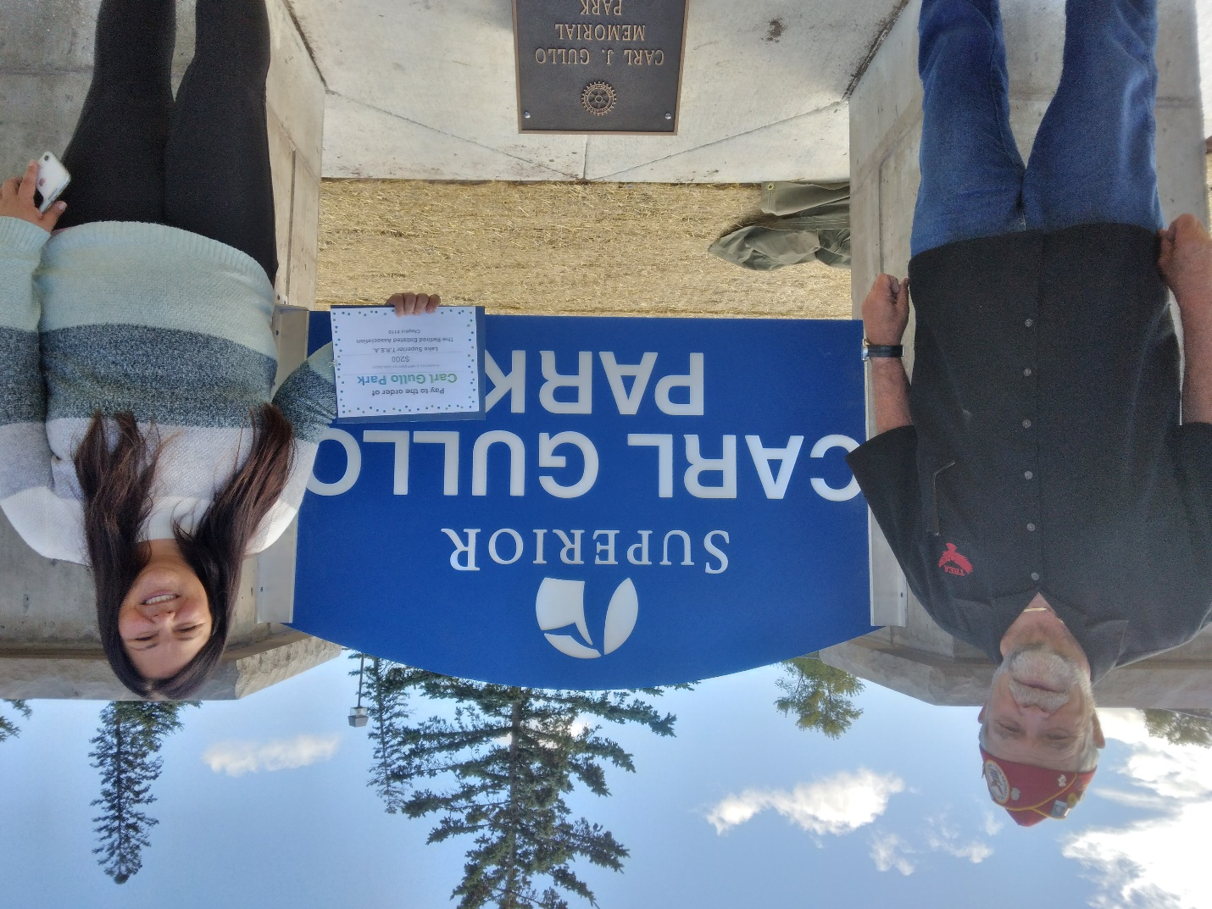

**Park sign for Carl Gullo**

**Pictured next to the new replacement sign for the Carl Gullo City Park are Counselor Jennie Van Sickle and Butch Liebaert, Chapter 119 President. Chapter 119 donated money to replace the original sign as it was deteriorating. The city park is the only park in Superior to be named after a Veteran. Mr. Gullo served in the Army as a paratrooper from 1940 to 1945. He returned from serving his country and taught at WITC.**